Download Vmware Workstation for Windows and install

<https://www.techspot.com/downloads/189-vmware-workstation-for-windows.html>

* Check above blog, and install VMware Workstation on your personal laptop
* Download ubuntu 22.04

[https://releases.ubuntu.com/22.04/?_gl=1*18xj4v4*_gcl_au*MTc2NDg4Nzk3NS4xNzIzNDM1Nzcw&_ga=2.238615232.1313284686.1723435768-641863381.1723435768](https://releases.ubuntu.com/22.04/?_gl=1*18xj4v4*_gcl_au*MTc2NDg4Nzk3NS4xNzIzNDM1Nzcw&_ga=2.238615232.1313284686.1723435768-641863381.1723435768)

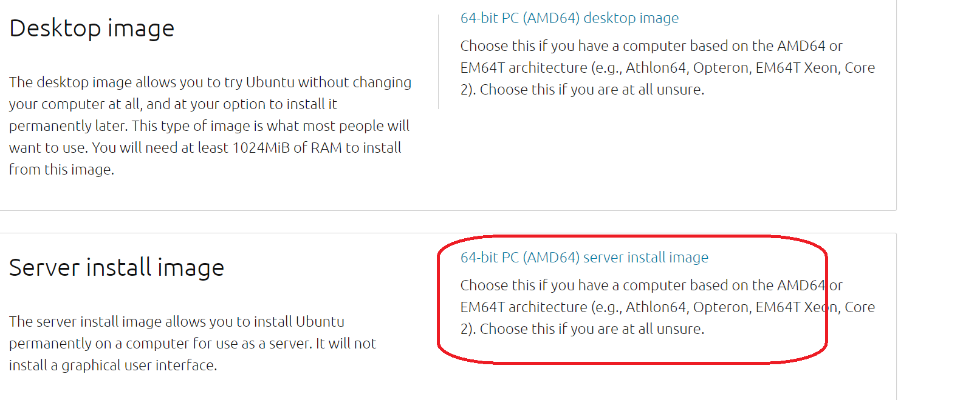

Image name: ubuntu-22.04.4-live-server-amd64.iso

Open VMware Workstation, and click

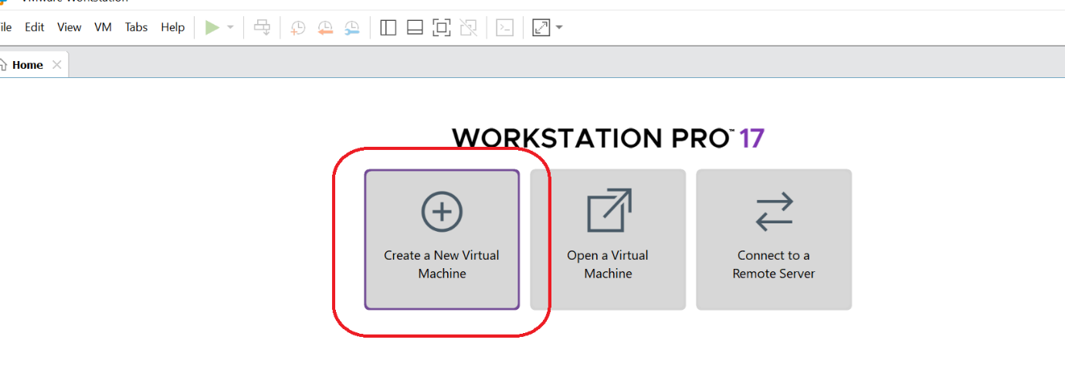

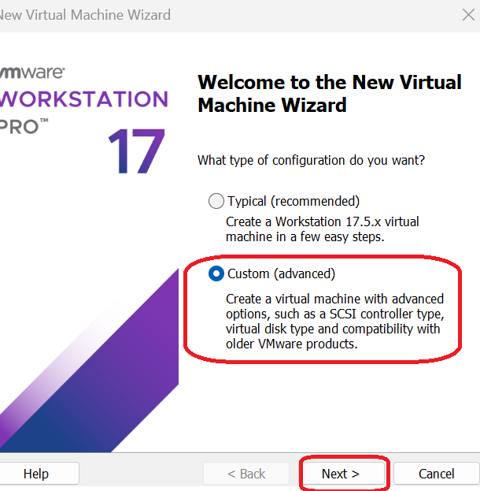

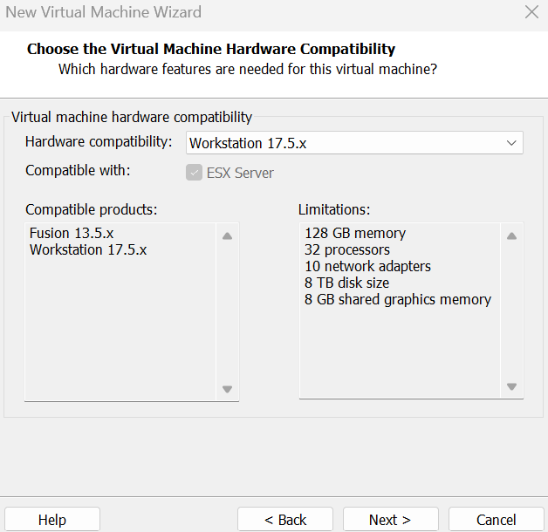

Select the iso which you downloaded

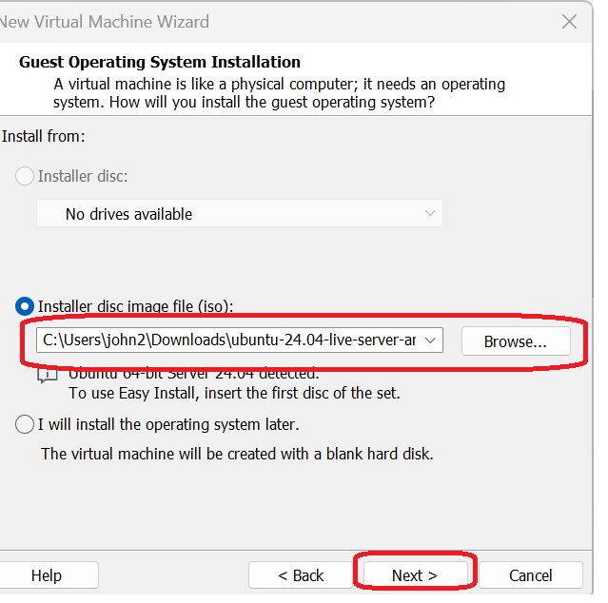

Provide a name and location

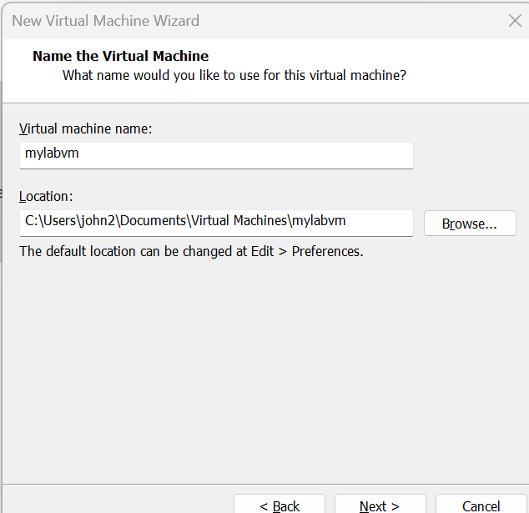

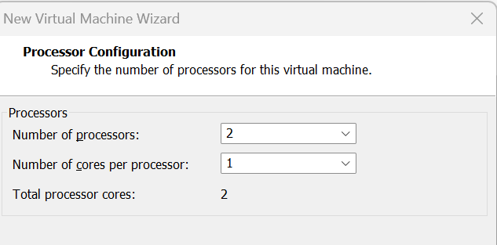

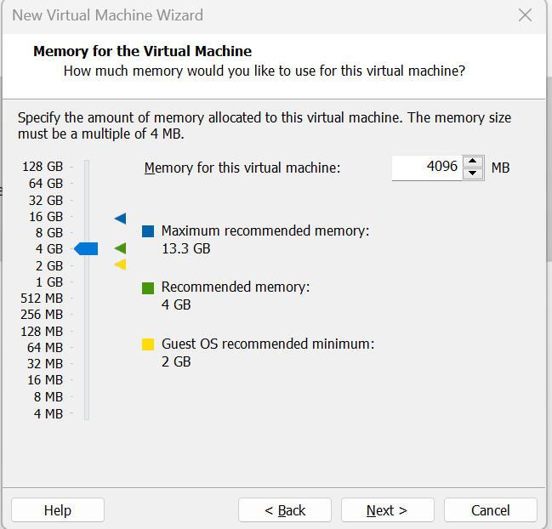

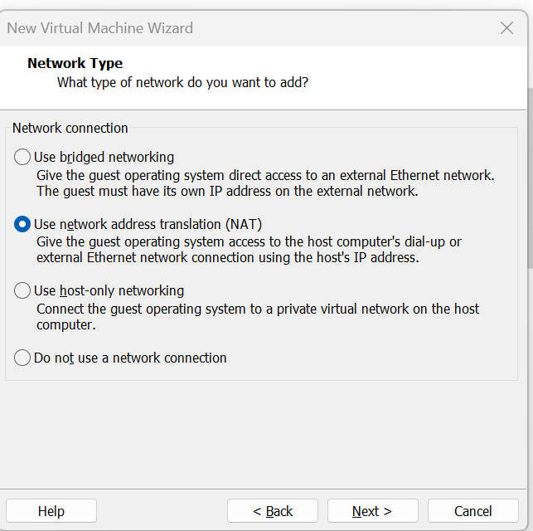

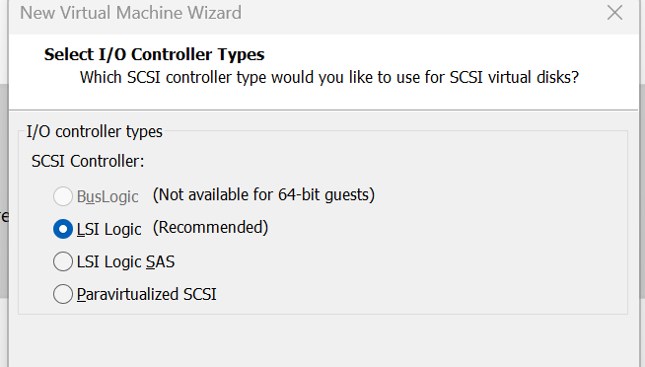

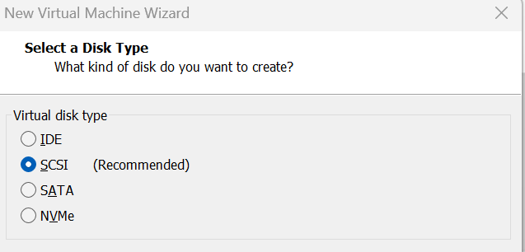

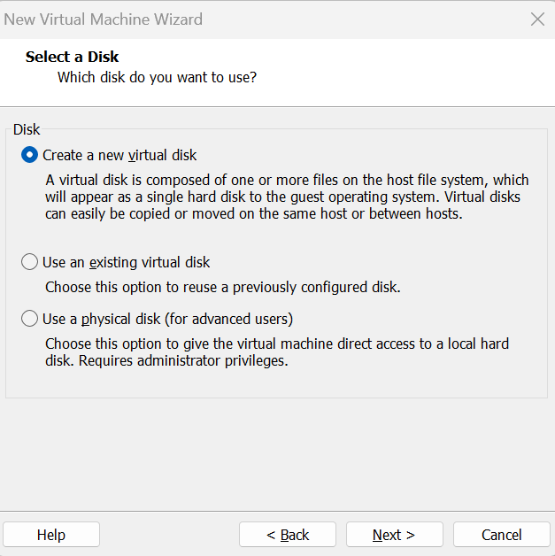

50 HD, and store as single file

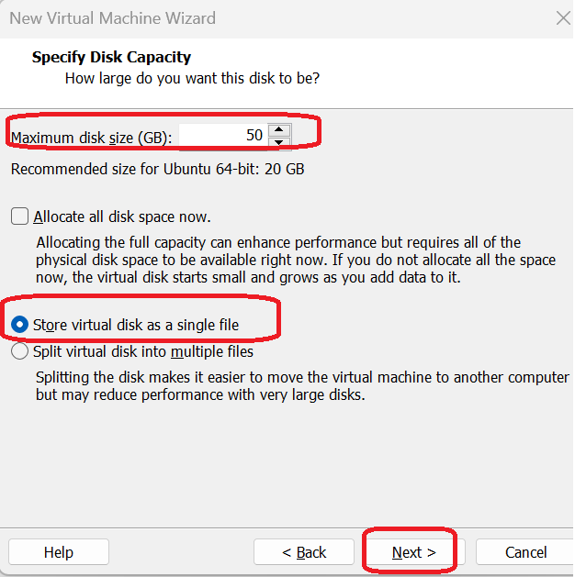

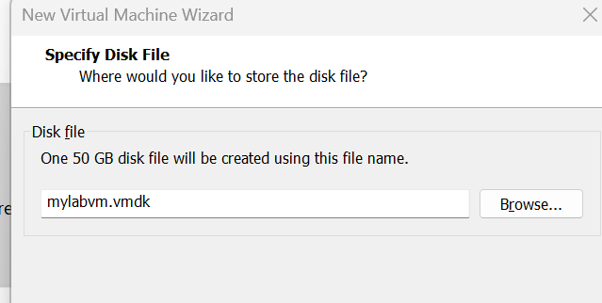

Click on finish

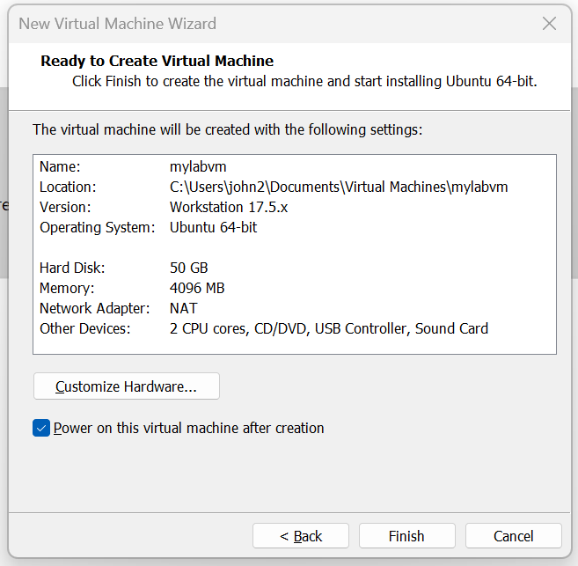

Using keyboard, Enter on Install ubuntu server

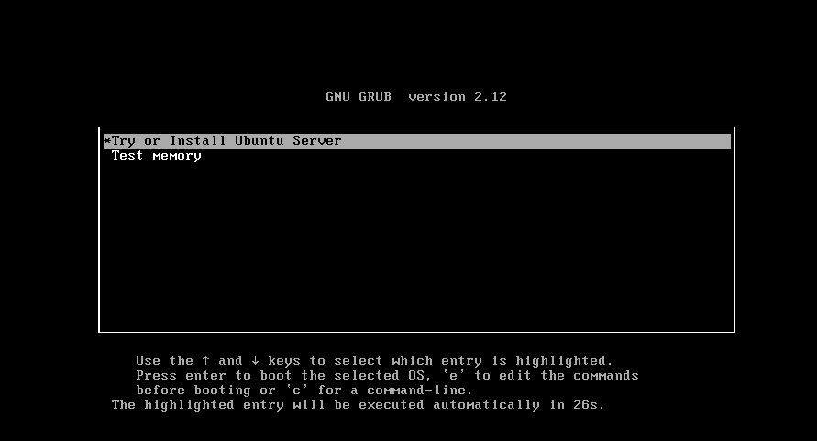

Select the language and press enter

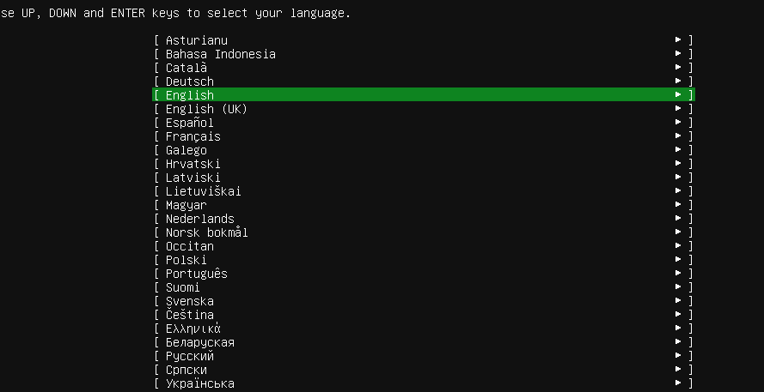

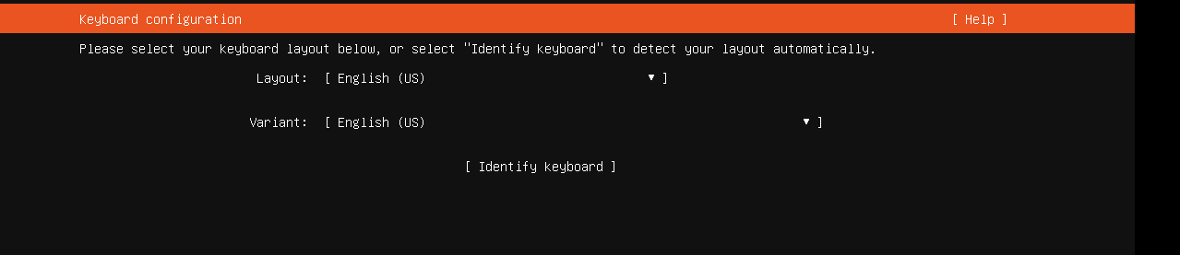

Press enter

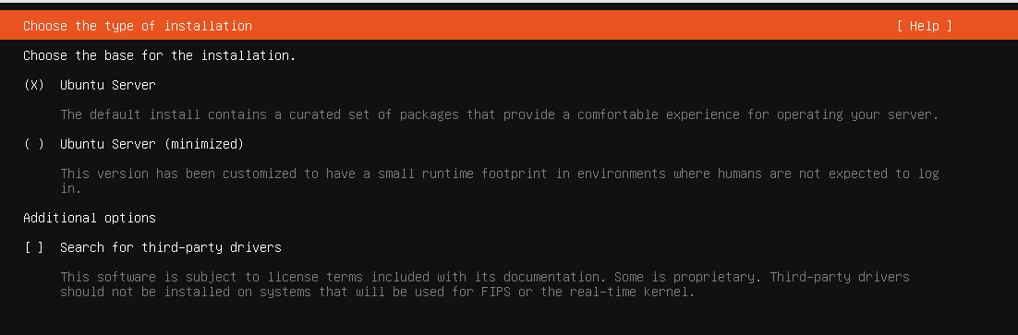

Default ip range, press enter

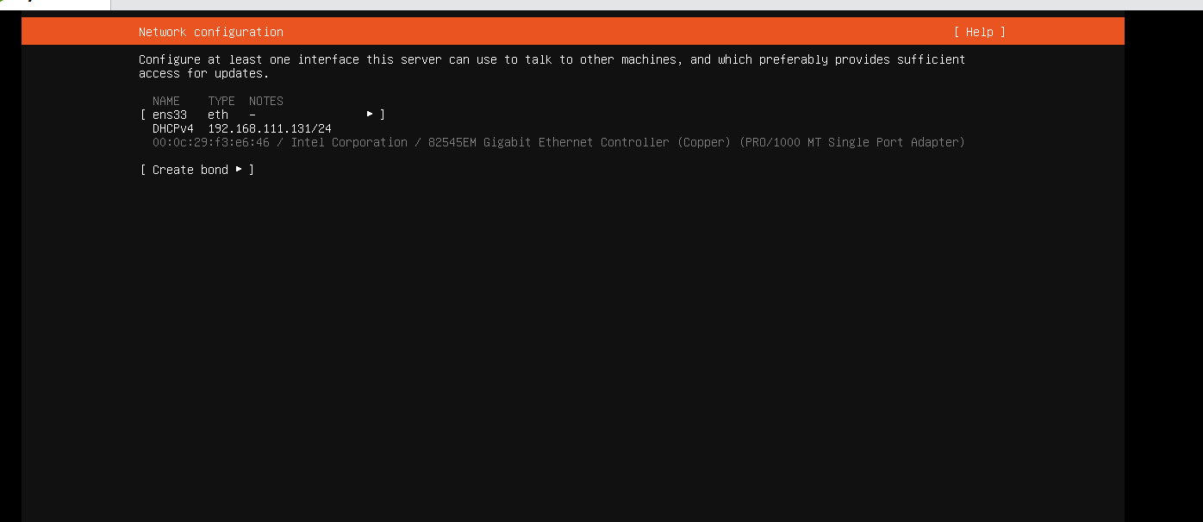No proxy

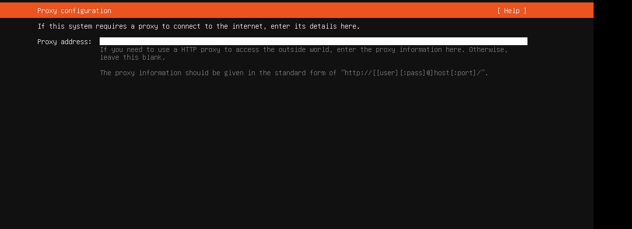

Press Enter

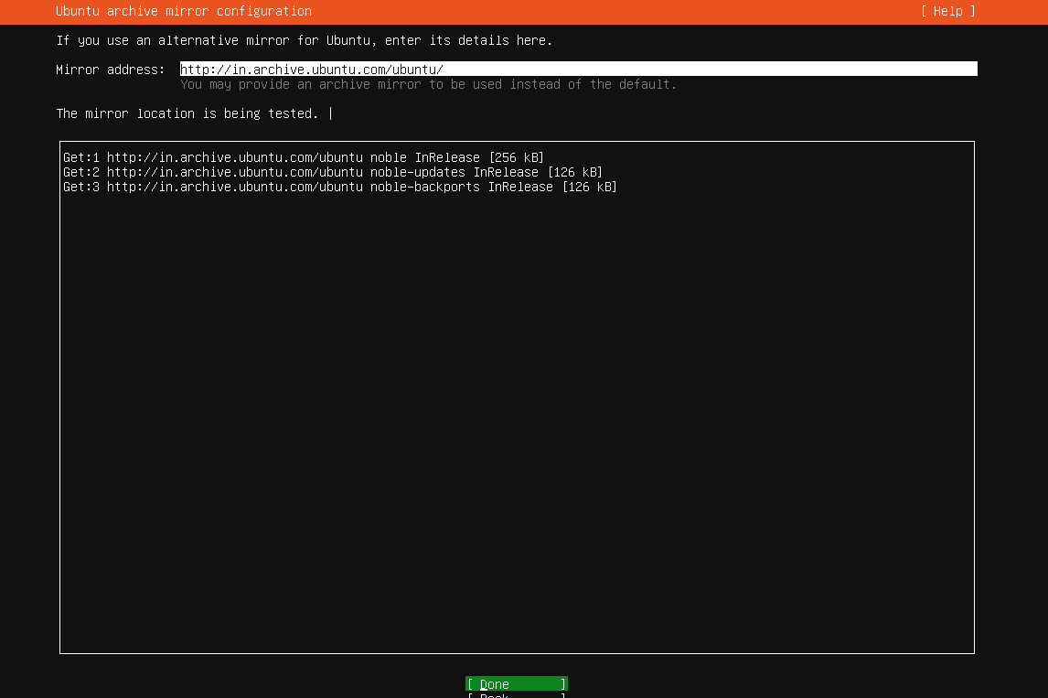

Using Tab go to done, and press Enter

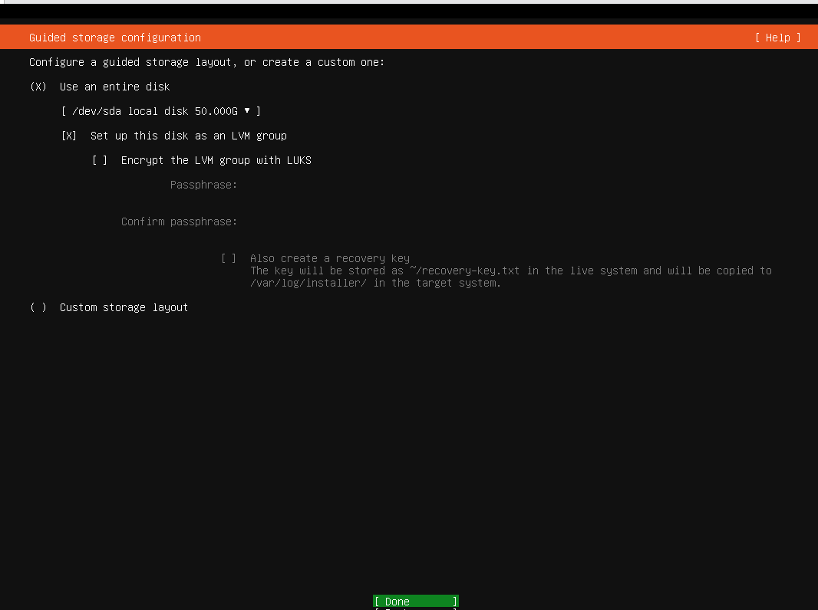

Enter on Continue

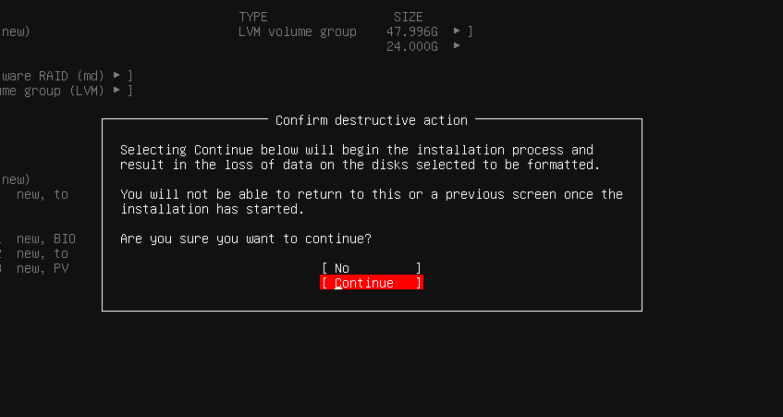

Fill the profile detail and using tab go to done, and press Enter

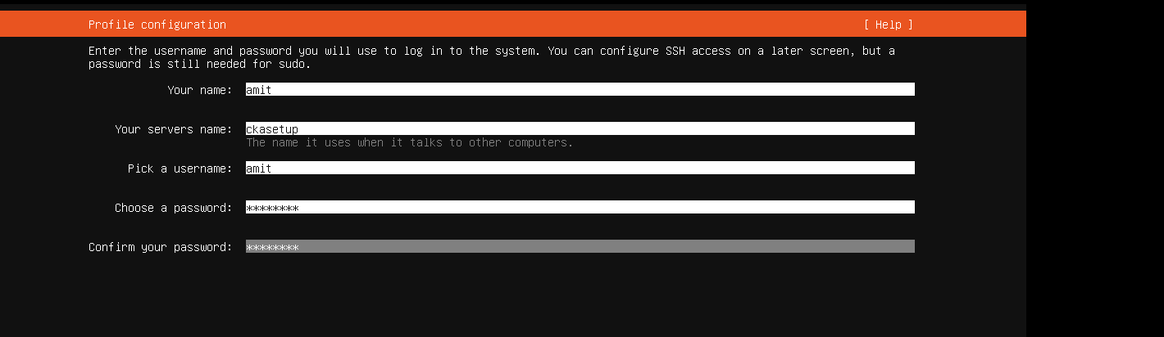

Press enter

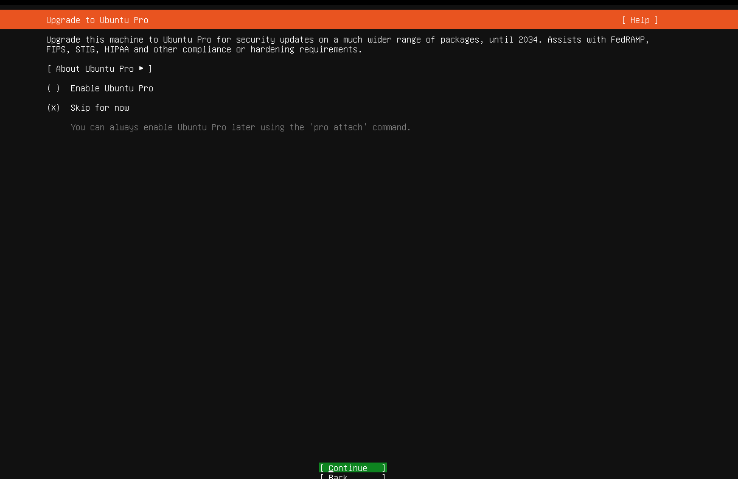

Using Space bar , select insall openssh , press tab and Enter on done

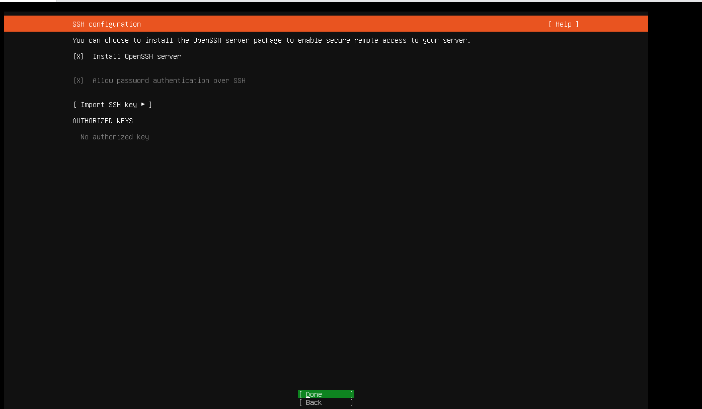

No need to select any module, press tab and enter on done

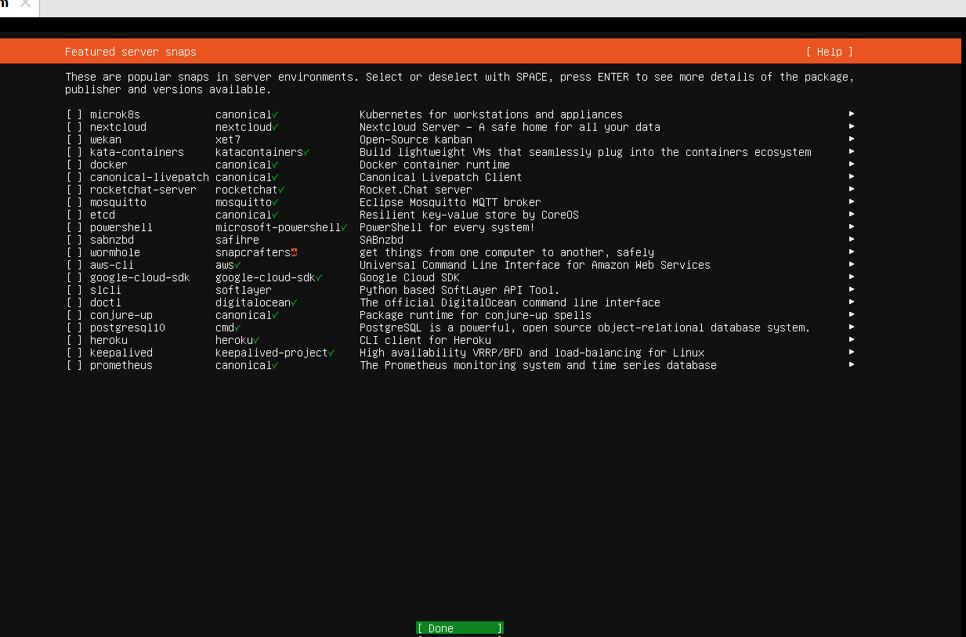

Once Installation is finished, press tab and enter on reboot now

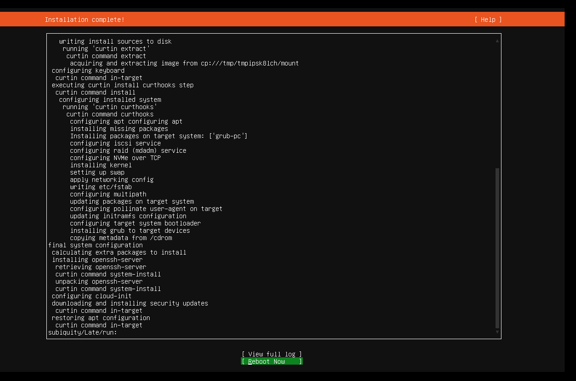

Press Enter

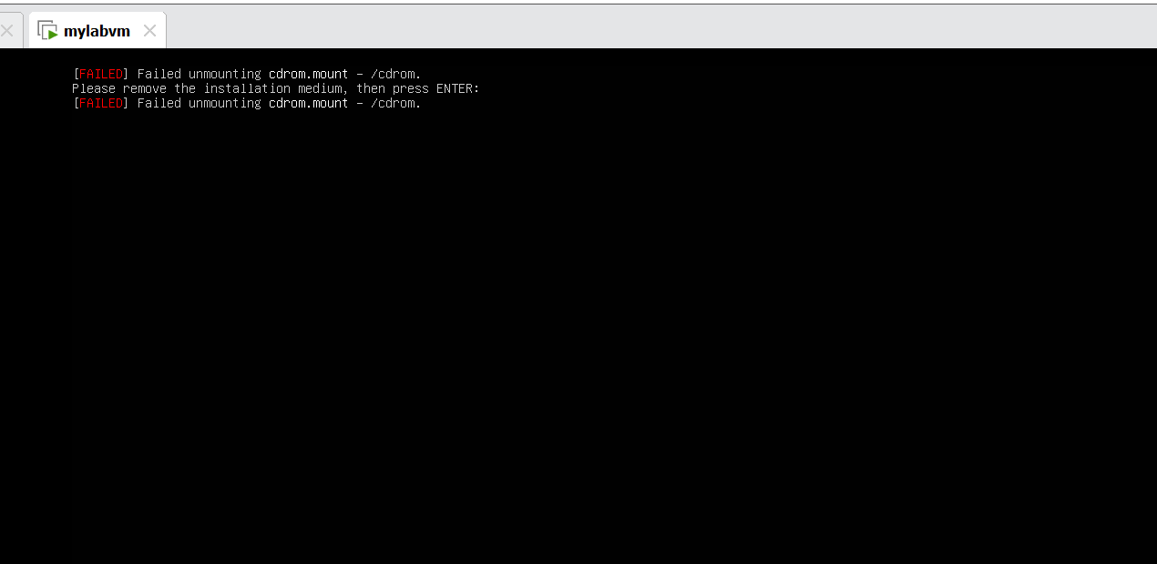

Once system is booted, login with your user



Note down the ip address

